**DAY15-ASSIGNMENT**

**NAME: SUDHA SREELATHA**

**EMP ID: 46255249**

**Assignment 1 –** Create a Simple program to fetch data and display ALV using Std. SAP class-methods.

**Scenario** –

* Create a Custom program using ECLIPSE. Select data from table SNWD_PD.
* The output should consist three columns – Category, Max price and Average price.
* The data should consist of all categories from SNWD_PD, with maximum price for each category and average price for each category.
* There should be only 1 select statement used to achieve this using In-line Declaration, CASE, Aggregate, HAVING and GROUP BY clauses as needed.
* Selection screen can contain CATEGORY
* Output should be in ALV Grid format.

**Tables involved** – SNWD_PD / Columns – CATEGORY & PRICE.

**CODE:**

REPORT z249_alv_p1.

TABLES SNWD_PD.

SELECT-OPTIONS S_CAT FOR SNWD_PD-CATEGORY.

DATA: IT_FCAT TYPE SLIS_T_FIELDCAT_ALV,

WA_FCAT TYPE SLIS_FIELDCAT_ALV.

SELECT CATEGORY, MAX ( PRICE ) AS MAX_PRICE, AVG( PRICE )

AS AVG_PRICE FROM SNWD_PD WHERE CATEGORY IN @ S_CAT GROUP BY CATEGORY

INTO TABLE @DATA(IT_PRODUCT).

START-OF-SELECTION.

PERFORM BUILD_FCAT.

PERFORM DISP_ALV.

FORM BUILD_FCAT.

WA_FCAT-COL_POS = '1'.

WA_FCAT-FIELDNAME = 'CATEGORY'.

WA_FCAT-SELTEXT_M = 'Category'.

APPEND WA_FCAT TO IT_FCAT.

CLEAR WA_FCAT.

WA_FCAT-COL_POS = '2'.

WA_FCAT-FIELDNAME = 'MAX_PRICE'.

WA_FCAT-SELTEXT_M = 'Maximum Price'.

APPEND WA_FCAT TO IT_FCAT.

CLEAR WA_FCAT.

WA_FCAT-COL_POS = '3'.

WA_FCAT-FIELDNAME = 'AVG_PRICE'.

WA_FCAT-SELTEXT_M = 'Average Price'.

APPEND WA_FCAT TO IT_FCAT.

CLEAR WA_FCAT.

ENDFORM.

FORM DISP_ALV.

CALL FUNCTION 'REUSE_ALV_GRID_DISPLAY'

EXPORTING

it_fieldcat = IT_FCAT " Field catalog with field descriptions

TABLES

t_outtab = IT_PRODUCT " Table with data to be displayed

.

IF sy-subrc <> 0.

MESSAGE 'Error in function call' TYPE 'I'.

ENDIF.

ENDFORM.

**OUTPUT:**

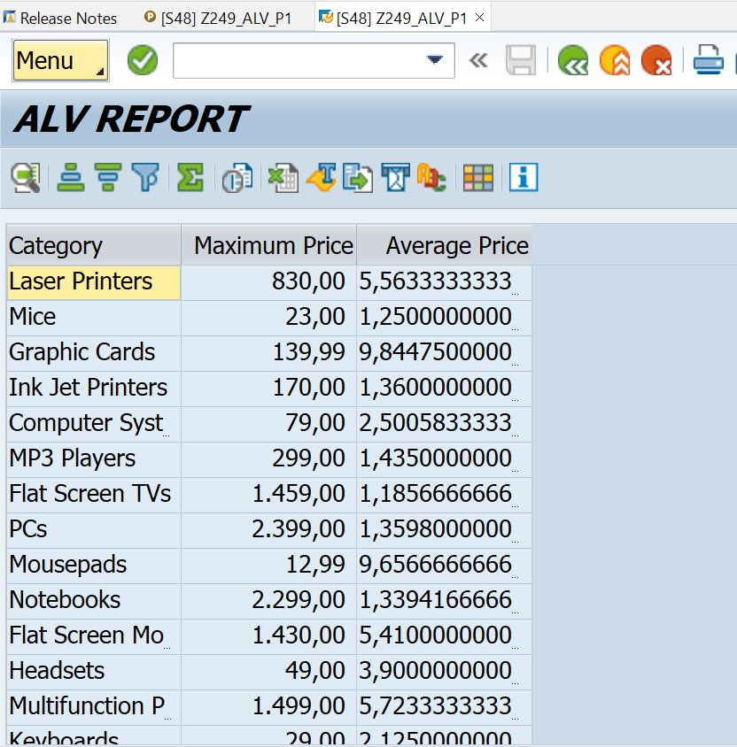

**Assignment 2 –** ALV with IDA

**Scenario** –

* Create one CDS view by selecting fields VBELN, POSNR, VKORG, MATNR, MENGE from VBAK and VBAP table
* Perform below operations using IDA framework

1. Create select-options based on MATNR for selection screen
2. Fetch records from CDS view in ABAP program
3. Pass user input (select-option entries) to filter record accordingly
4. Hide POSNR field from display
5. Change label of VBELN as SOrder, VKORG as SOrganization, and MENGE as TotalQuantity
6. Disable standard function SORT for MATNR field
7. Hide standard toolbar FILTER
8. Set title as “ALV report with IDA, CDS consumption”
9. Enable ZEBRA pattern
10. Multiple row selection should be enabled

**Tables involved** – VBAP, VBAK.

**CODE:**

REPORT z249_alv_p2.

tables: vbap,vbak.

select-options s_matnr for vbap-matnr.

DATA(OBJ) = CL_SALV_GUI_TABLE_IDA=>create_for_cds_view(

iv_cds_view_name = 'Z249CDSD14P2').

DATA(LV_RANGE) = NEW CL_SALV_RANGE_TAB_COLLECTOR( ).

LV_RANGE->add_ranges_for_name(

EXPORTING

iv_name = 'MATNR'

it_ranges = s_matnr[]

).

lv_range->get_collected_ranges(

IMPORTING

et_named_ranges = DATA(LO_NAMED_RANGES)

).

OBJ->set_select_options(

EXPORTING

it_ranges = LO_NAMED_RANGES

* io_condition =

).

* CATCH cx_salv_ida_associate_invalid. "

* CATCH cx_salv_db_connection. "

* CATCH cx_salv_ida_condition_invalid. "

* CATCH cx_salv_ida_unknown_name. "

OBJ->field_catalog( )->get_available_fields(

IMPORTING

ets_field_names = DATA(ITAB)

).

DELETE ITAB WHERE TABLE_LINE = 'POSNR'.

OBJ->field_catalog( )->set_field_header_texts(

EXPORTING

iv_field_name = 'VBELN'

iv_header_text = 'SOrder'

iv_tooltip_text = 'Sales Order'

* iv_tooltip_text_long =

).

* CATCH cx_salv_ida_unknown_name. "

* CATCH cx_salv_call_after_1st_display. "

obj->field_catalog( )->set_field_header_texts(

EXPORTING

iv_field_name = 'VKORG'

iv_header_text = 'SOrganization'

iv_tooltip_text = 'Sales Organization'

* iv_tooltip_text_long =

).

* CATCH cx_salv_ida_unknown_name. "

* CATCH cx_salv_call_after_1st_display. "

obj->field_catalog( )->set_field_header_texts(

EXPORTING

iv_field_name = 'ZMENG'

iv_header_text = 'POrder'

iv_tooltip_text = 'Purchase Order Details'

* iv_tooltip_text_long =

).

* CATCH cx_salv_ida_unknown_name. "

* CATCH cx_salv_call_after_1st_display. "

obj->field_catalog( )->disable_sort( iv_field_name = 'MATNR' ).

* CATCH cx_salv_ida_unknown_name. "

* CATCH cx_salv_call_after_1st_display. "

OBJ->toolbar( )->set_visibility_std_functions(

EXPORTING

* iv_details = ABAP_UNDEFINED

* iv_sort = ABAP_UNDEFINED

* iv_group = ABAP_UNDEFINED

iv_filter = '' "ABAP_UNDEFINED

* iv_aggregation = ABAP_UNDEFINED

* iv_print = ABAP_UNDEFINED

* iv_export = ABAP_UNDEFINED

* iv_settings_dialog = ABAP_UNDEFINED

).

OBJ->display_options( )->set_title( iv_title = 'ALV report with IDA, CDS consumption' ).

OBJ->display_options( )->enable_alternating_row_pattern( ).

OBJ->selection( )->set_selection_mode(

iv_mode = 'MULTI'

).

* CATCH cx_salv_ida_contract_violation. "

OBJ->fullscreen( )->display( ).

**OUTPUT:**

